Sprint 1 - Endurance Design Document

March 28, 2022

Table of Contents
1. Executive Summary 3
1.1 Project Overview 3
1.2 Purpose and Scope of this Specification 3
2. Product/Service Description 3
2.1 Product Context 3
2.2 User Characteristics 3
2.3 Assumptions 3
2.4 Constraints 3
2.5 Dependencies 4
3. Requirements 4
3.1 Functional Requirements 4
3.2 Security 5
3.2.1 Protection 5
3.2.2 Authorization and Authentication 5
3.3 Portability 5
4. Requirements Confirmation/Stakeholder sign-off 5
5. System Design 6
5.1 Algorithm 6
5.2 System Flow 6
5.3 Software 6
5.4 Hardware 6
5.5 Test Plan 6
5.6 Task List/Gantt Chart 6
5.7 Staffing Plan 6

Executive Summary

Project Overview
This project is intended to make a robot compete with others in a Triathlon and in the end, win the whole thing.

Purpose and Scope of this Specification
The purpose is to see how well and far the robot can make it. It will be competing after

In scope

Out of Scope
The following items in phase 3 of Project A are out of scope:
- modification of Classification Processing to meet legislative mandate XYZ.
- modification of Labor Relations Processing to meet legislative mandate XYZ

Product/Service Description

Product Context
This product is meant to travel around the class and make it back to its original location. This product moves at a great pace to make it back. It would require improvement but has the potential for the triathlon.

User Characteristics
Some profiles that worked on this project and need a mention are:
- Ryan Huitzil
- Alejandro Suarez

Assumptions
Some ways the testing doesn’t go planned would be if the room wasn’t available, robot wasn’t fully charged, and user experience with the robot.

Constraints
Some constrains the design has been:
- Robot sometimes disconnects due to app having bugs
- Must stay on application so robot doesn’t disconnect
- Desks were in the way
- Code block was at times confusing

Dependencies
- This new product will require a daily download of data from the app to function
- Module 1 needs to be completed before running the test to do a full run around the class

Requirements

Functional Requirements

Req# | Requirements | Comments | Priority | Date Rvwd | SME Reviewed / Approved
ENDUR_01 | To successfully travel around HH208 | Robot had difficulties but made it | 1 | 03/28 | Reviewed
ENDUR_02 | Robot much travel to each of the yellow floor tiles and turn right at the center of each tile and much return to its original spot | Robot | 2 | 03/28 | Reviewed
ENDUR_03 | Start with a green light and say “ready, set, go” |  | 3 | 03/28 | Approved
ENDUR_04 | Stop with red and say “I’m done and need water” |  | 3 | 03/28 | Approved
ENDUR_XX

Security

Protection
- encryption
- activity logging, historical data sets
- Having the code in a file

Authorization and Authentication

Portability
- Percentage of components with host-dependent code;
- Percentage of code that is host dependent;
- Use of a proven portable language;
- Use of a particular compiler or language subset;
- Use of a particular operating system;
- The need for environment-independence - the product must operate the same regardless of operating systems, networks, development or production environments.

Requirements Confirmation/Stakeholder sign-off
Include documentation of the approval or confirmation of the requirements here. For example:
Meeting Date | Attendees (name and role) | Comments
03/24/22 | Ryan H, Filling out SDD Document | Almost completed
03/28/22 | Alejandro S, Block Code/Algorithm | After test runs, having a good block code

System Design

Algorithm
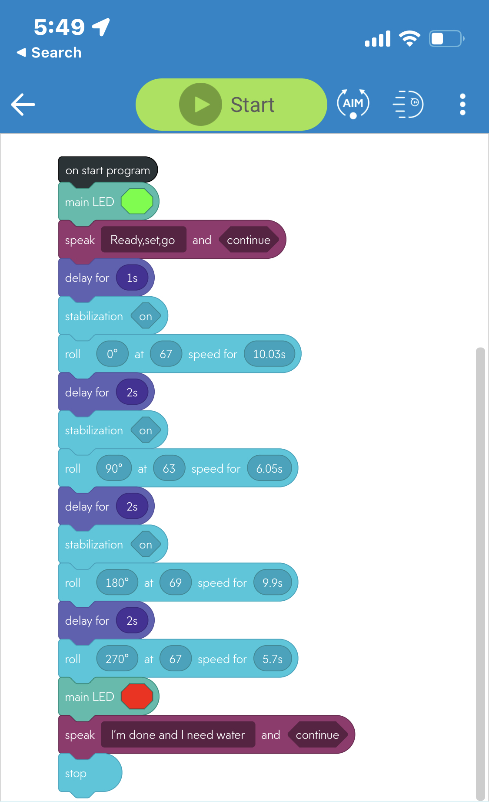

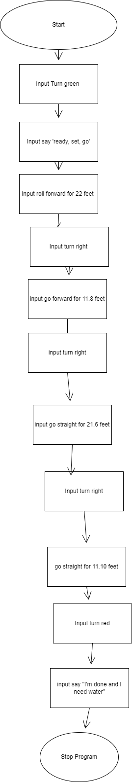

System Flow

Software
Sphero edu was the app used to signal the directions for the robot. It’s also where the block code was created.

Hardware
Robot was used and as well as the laptop to record the steps that followed.

Test Plan

Reason for Test Case | Test Date | Expected Output | Observed Output | Staff Name | Pass/Fail
First Straight-line test | 03/28 | To make it to the corner | It made it to its destination | Alejandro | Pass
Robot expected to turn right and it to the corner | 03/28 | To reach corner | It almost made it | Alejandro | Fail
Robot to do a turn and stop | 03/28 | To reach the corner | It made it’s destination | Alejandro | Pass
To make robot reach second to last corner | 03/28 | To be near the end of the course | It made it to it’s destination | Alejandro | Pass
Return to its original place | 03/28 | Robot must return to its original location | It over passed it | Alejandro | Fail
Returning to its original spot | 03/28 | Robot must be where I started | It made a perfect complete run | Alejandro | Pass

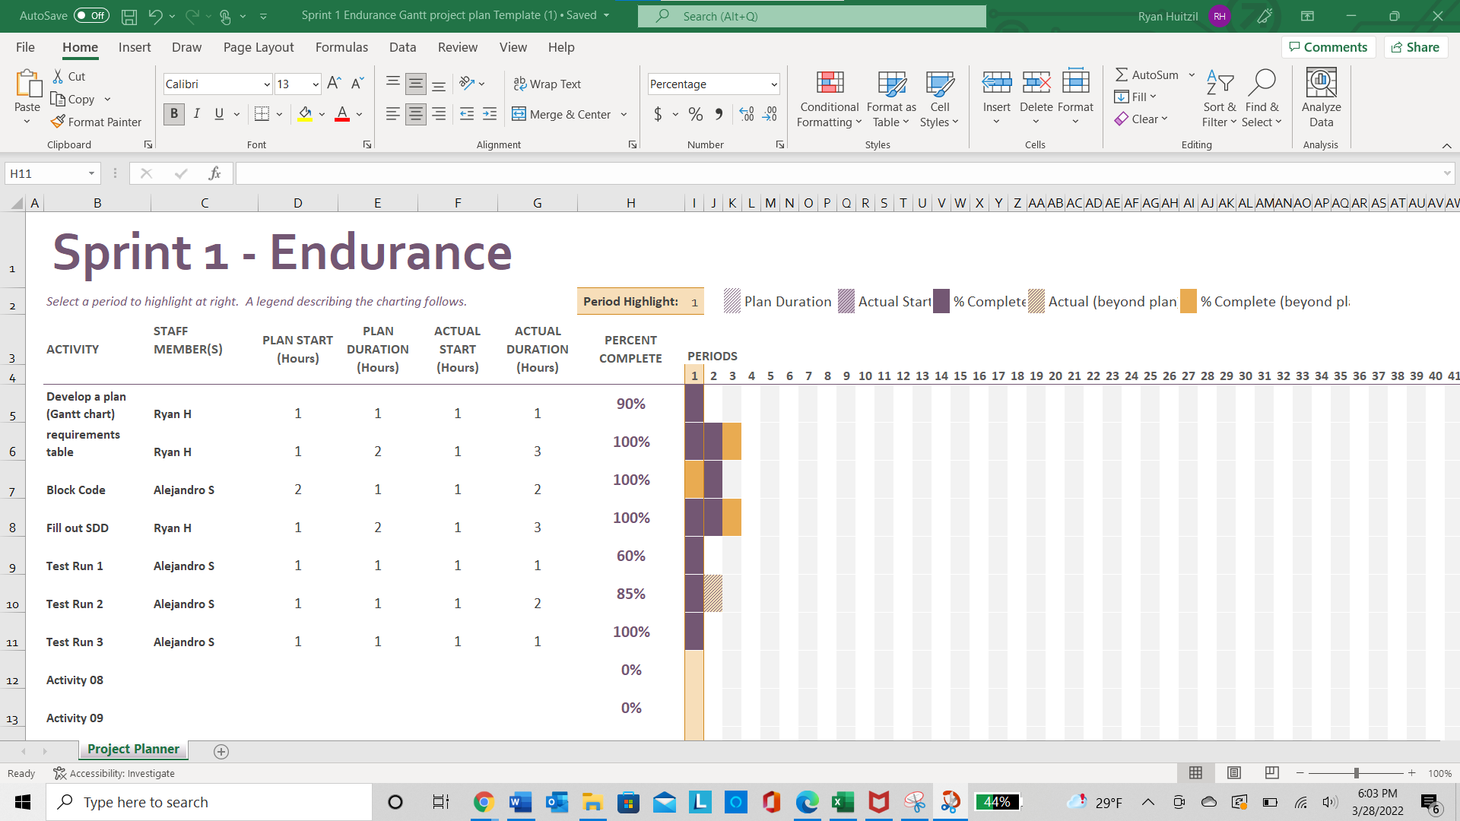
Task List/Gantt Chart

Staffing Plan
Insert a chart/table that depicts the roles and responsibilities of each team member that worked on this project

Name | Role | Responsibility | Reports To
Ryan H | Filling out charts | Record data for the charts | Git Hub
Alejandro S | Doing the algorithm | Block code | Ryan

